Upcoming Events:  March 11: Small group gathering; 1:30 at church. Please join us for this 6-week session. We will be discussing two of the fruits of the spirit (Galatians 5: 22-23) each week. This week is Love and Joy.  March 11: Council Meeting at 6:00 at church.  March 15: Coffee and Conversation 9-11 at church  Birthday: “God Bless You and Keep You Another Year Through”  Dennis Murphy March 11  Anniversary:  Daryl and Roxanne Thompson March 11  If you wish to donate to the church, we now have the collection plate on the table by the entrance to the League Room. Or you can use our on-line giving option found on our website.  Pastor Jinkyoung You  Office Hours: Monday, Tuesday and Thursday 1-3:30 p.m.  Days off: Friday and Saturday  Email: holistic78@gmail.com  Phone number: 608-455-3344 M-Th 9-4. If you need to reach her at other times, please use her private number 1-256-631-9906. Texting is best if possible.  Email: brooklyncommunityumc@gmail.com  Facebook: Brooklyn Community UMC  Website: http://www.brooklynumc.org/ |  |  | 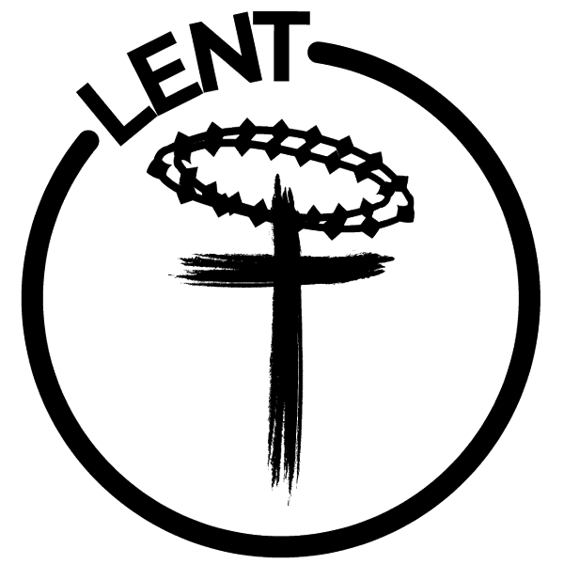  March 9, 2025  Brooklyn Community United Methodist Church  Pastor Jinkyoung You
Welcome to  Brooklyn Community United Methodist Church  March 9, 2025  First Sunday in Lent  Minister: Pastor Jinkyoung You  Reader: Julie Anderson  Pianist: Debbie Schneider  Percussionist: Dennis Murphy  Welcome & Greetings  Birthdays, Anniversaries & Announcements  Prelude  CALL TO WORSHIP (Congregation reads the bold)  From the very beginning, God created all in love.  Yet we turned from that love and sought our own way.  God continues to call us to return again to God’s love.  How shall we return?  Let us cast down our burdens  For God promises to gather them up.  Let us place our trust in God.  For God alone provides for our every need.  Opening Prayer  *Hymn of Praise “Cares Chorus” 2 Times TFWS #2215  Joys and Concerns  Pastoral Prayer/The Lord’s Prayer |  |  | *Hymn of Response UMH #292  “What Wondrous Love Is This”  Children’s Time  Scripture Readings John 3: 1-17 (CEB)  Congregation Response: Thanks be to God.  “I Believe” Jim Brown  Message Pastor Jinkyoung  “The Grace That Transforms”  *Offering/Doxology UMH #95  *Hymn of Affirmation UMH #393  “Spirit of the Living God” Two Times  Benediction  Postlude  *Stand if you are able.  Please join us for refreshments in our fellowship hall after the service.  UMH United Methodist Hymnal  TFWS In Faith We Sing

