Upcoming Events:  March 25: Small group gathering; 1:30 at church. Please join us for this 5-week session. We will be discussing two of the fruits of the spirit (Galatians 5: 22-23) each week. This week is Goodness and Faithfulness.  March 27: Community Potluck at noon; bring a dish to pass; table service and beverage provided  March 29: Coffee and Conversation 9-11 at church  Birthday: “God Bless You and Keep You Another Year Through”  Ila Stephenson March 26  If you wish to donate to the church, we now have the collection plate on the table by the entrance to the League Room. Or you can use our on-line giving option found on our website.  Pastor Jinkyoung You  Office Hours: Monday, Tuesday and Thursday 1-3:30 p.m.  Days off: Friday and Saturday  Email: holistic78@gmail.com  Phone number: 608-455-3344 M-Th 9-4. If you need to reach her at other times, please use her private number 1-256-631-9906. Texting is best if possible.  Email: brooklyncommunityumc@gmail.com  Facebook: Brooklyn Community UMC  Website: http://www.brooklynumc.org/ |  |  | 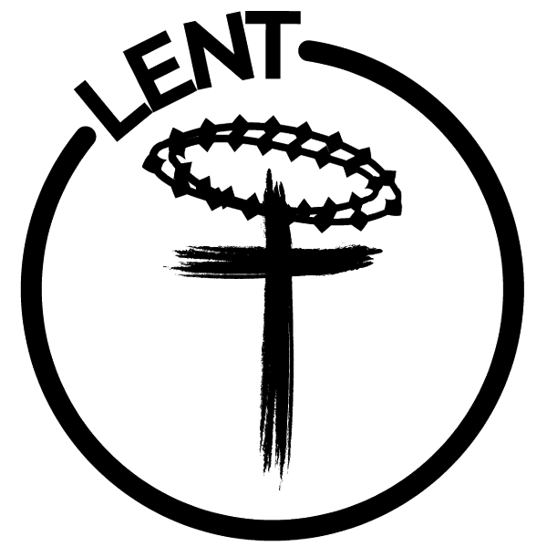  March 23, 2025  Brooklyn Community United Methodist Church  Pastor Jinkyoung You
Welcome to  Brooklyn Community United Methodist Church  March 23, 2025  Third Sunday in Lent  Minister: Pastor Jinkyoung You  Reader: Pat Wilkening  Pianist: Debbie Schneider  Percussionist: Dennis Murphy  Welcome & Greetings  Birthdays, Anniversaries & Announcements  Prelude  CALL TO WORSHIP (Congregation reads the bold)  Come, people of God, open your eyes to see the world as Jesus sees.  Lord, give us eyes to see the needs of others.  Where there is suffering, may we see an opportunity to serve.  Where there is pain, may we bring Your healing touch.  Too often, we pass by, blind to the struggles of our neighbors.  Open our hearts, O God, that we may love as You love.  Jesus saw the blind man, not as a sinner, but as one through whom God's work would be revealed.  May we see the image of God in every person we meet.  Let us worship the One who heals, restores, and calls us to serve.  We come to worship with open hearts and willing hands. Amen.  Opening Prayer  *Hymn of Praise UMH #451  “Be Thou My Vision” |  |  | Joys and Concerns  Pastoral Prayer/The Lord’s Prayer  *Hymn of Response UMH #454  “Open My Eyes, That I May See”  Children’s Time  Scripture Readings John 9:1-25 (CEB)  Congregation Response: Thanks be to God.  “What a Friend WE Have in Jesus”  Redeemed Quartet  Requested by Jan Witzel  Message Pastor Jinkyoung  “Grace That Heals Our Blindness”  *Offering/Doxology UMH #95  *Hymn of Affirmation “Amazing Grace” UMH #378  Benediction  Postlude  *Stand if you are able.  Please join us for refreshments in our fellowship hall after the service.  UMH United Methodist Hymnal  TFWS The Faith We Sing

