Upcoming Events:  March 18: Small group gathering; 1:30 at church. Please join us for this 5-week session. We will be discussing two of the fruits of the spirit (Galatians 5: 22-23) each week. This week is Peace and Patience.  March 20: Breakfast at Farm 42; 9:00 a.m. Supporting our local business.  March 22: Coffee and Conversation 9-11 at church  Birthday: “God Bless You and Keep You Another Year Through”  Loran Klitzman March 19  If you wish to donate to the church, we now have the collection plate on the table by the entrance to the League Room. Or you can use our on-line giving option found on our website.  Pastor Jinkyoung You  Office Hours: Monday, Tuesday and Thursday 1-3:30 p.m.  Days off: Friday and Saturday  Email: holistic78@gmail.com  Phone number: 608-455-3344 M-Th 9-4. If you need to reach her at other times, please use her private number 1-256-631-9906. Texting is best if possible.  Email: brooklyncommunityumc@gmail.com  Facebook: Brooklyn Community UMC  Website: http://www.brooklynumc.org/ |  |  | 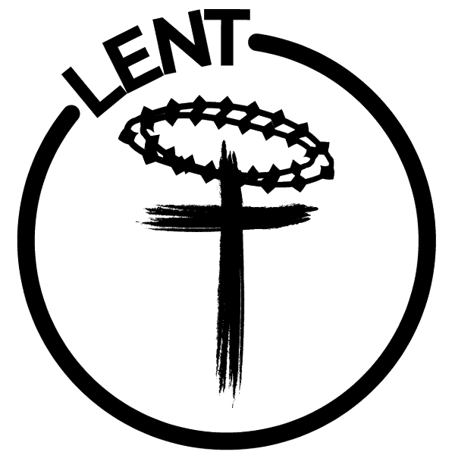  March 16, 2025  Brooklyn Community United Methodist Church  Pastor Jinkyoung You
Welcome to  Brooklyn Community United Methodist Church  March 16, 2025  Second Sunday in Lent  Minister: Pastor Jinkyoung You  Reader: Jo-Ann Draheim  Pianist: Debbie Schneider  Percussionist: Dennis Murphy  Welcome & Greetings  Birthdays, Anniversaries & Announcements  Prelude  CALL TO WORSHIP (Congregation reads the bold)  We come to the well of fear and doubt.  We have drawn deeply of those waters.  We come to the well of anger and hate.  These waters flourish in all the land.  Lord, bring us to the water of peace and hope.  Lord, bring us to the well of salvation. AMEN.  Opening Prayer  *Hymn of Praise TFWS #2145  “I’ve Got Peace Like a River”  Joys and Concerns  Pastoral Prayer/The Lord’s Prayer |  |  | *Hymn of Response “All Who Hunger” TFWS #2126  Children’s Time  Scripture Readings John 4:5-24 (CEB)  Congregation Response: Thanks be to God.  “Only You” Dennis Murphy  Message Pastor Jinkyoung  “Living Water: Grace for the Thirsty Soul”  *Offering/Doxology UMH #95  *Hymn of Affirmation “Fill My Cup, Lord” UMH #641  Benediction  Postlude  *Stand if you are able.  Please join us for refreshments in our fellowship hall after the service.  UMH United Methodist Hymnal  TFWS In Faith We Sing

