Upcoming Events:  February 18: Spiritual Formation at 1:30 at the parsonage Chapter 8  February 18: Finance meeting at 6:00 at church  February 22: Coffee and Conversation 9-11 at church  February 27: Community Potluck at noon  March 1: United Methodist Church Leadership Training 9-2 at People’s Church. Led by Barbara and Dan Dick. Open to current church leaders or anyone interested in the Methodist church. Lunch and snacks provided. Let Pastor Jinkyoung know if you are interested in attending.  Birthday: “God Bless You and Keep You Another Year Through”  Amanda Wallisch February 16  Carson Malkow February 18  If you wish to donate to the church, we now have the collection plate on the table by the entrance to the League Room. Or you can use our on-line giving option found on our website.  Pastor Jinkyoung You  Office Hours: Monday, Tuesday and Thursday 1-3:30 p.m.  Days off: Friday and Saturday  Email: holistic78@gmail.com  Phone number: 608-455-3344 M-Th 9-4. If you need to reach her at other times, please use her private number 1-256-631-9906. Texting is best if possible.  Email: brooklyncommunityumc@gmail.com  Facebook: Brooklyn Community UMC  Website: http://www.brooklynumc.org/ |  |  | 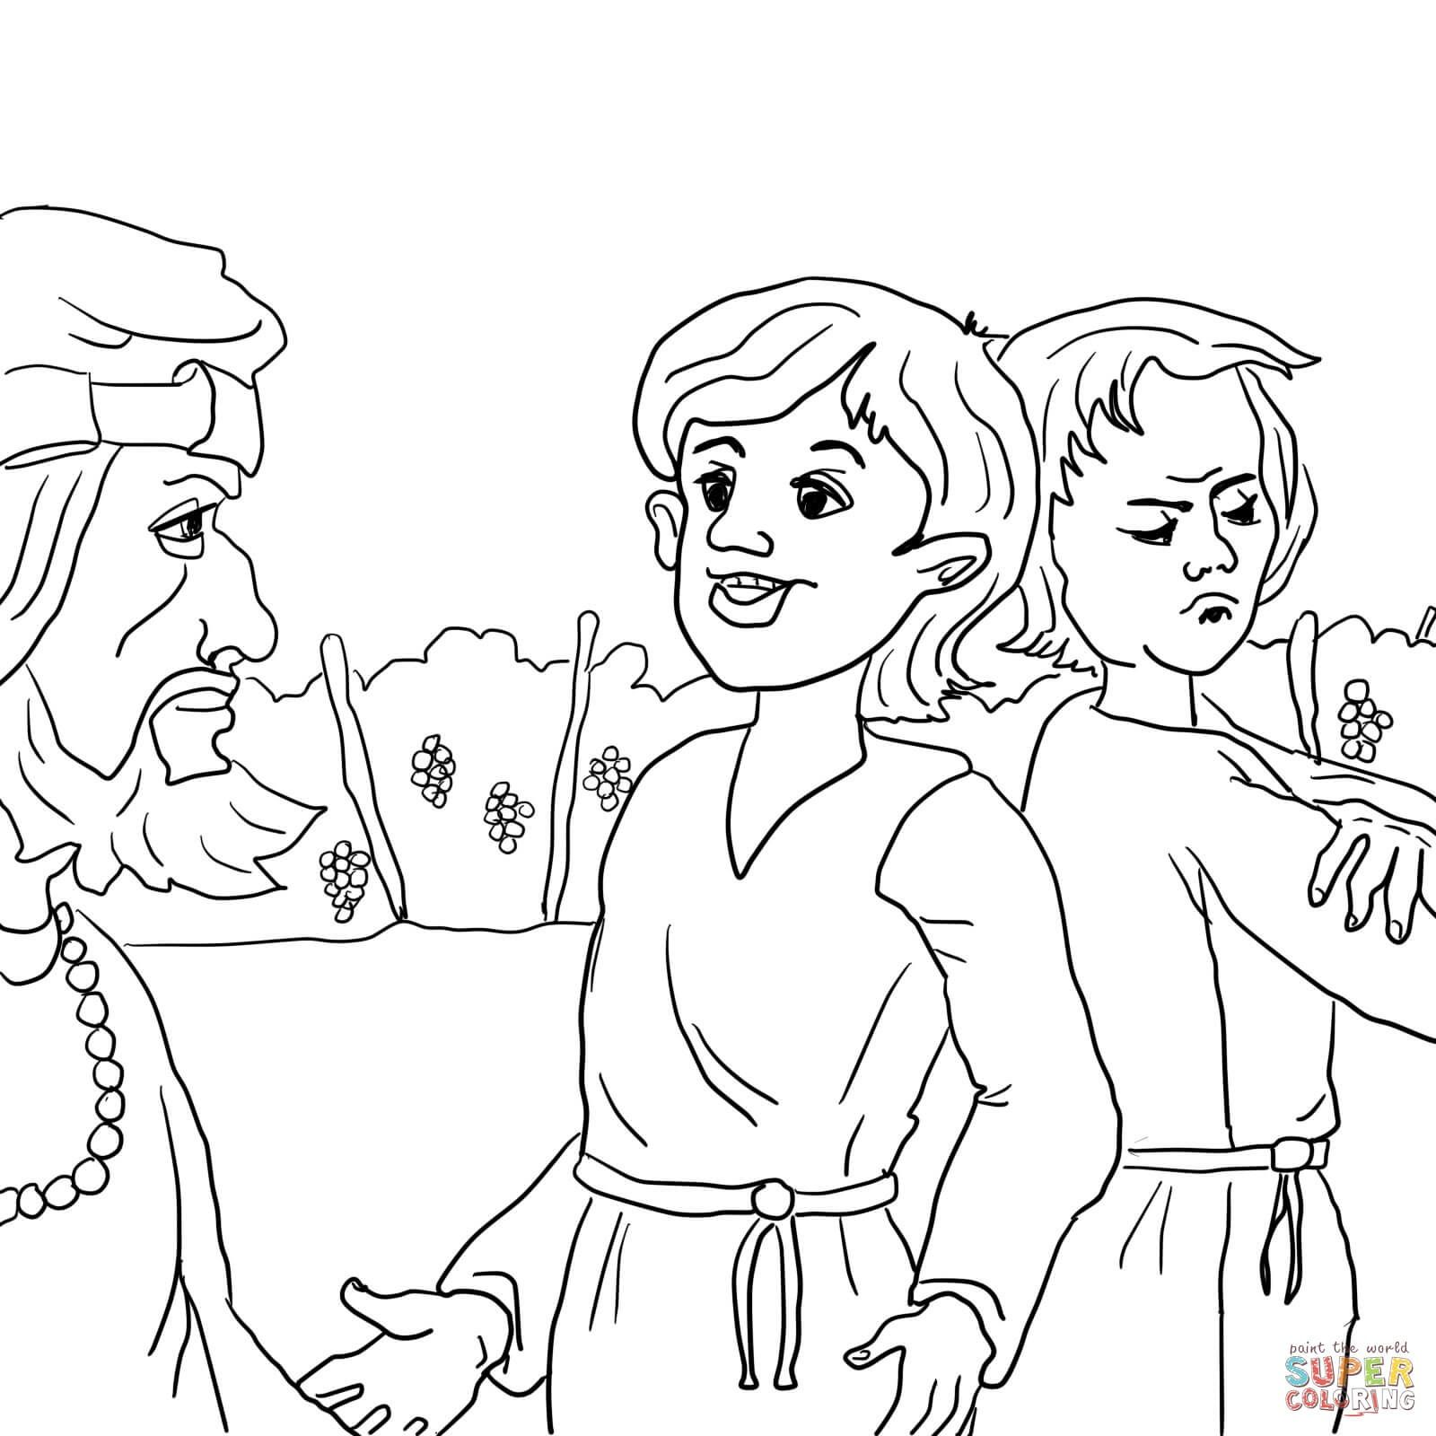  February 16, 2025  Brooklyn Community United Methodist Church  Pastor Jinkyoung You
Welcome to  Brooklyn Community United Methodist Church  February 16, 2025  Sixth Sunday after the Epiphany  Minister: Pastor Jinkyoung You  Reader: Julie Anderson  Pianist: Debbie Schneider  Percussionist: Dennis Murphy  Welcome & Greetings  Birthdays, Anniversaries & Announcements  Prelude  CALL TO WORSHIP (Congregation reads the bold)  We come before God as equal in God’s sight.  God knows us thoroughly and loves us completely.  None of us is perfect and without blemish.  Yet God has called us children and asked us to be compassionate and responsible in our caring and witness.  We are called to joyful obedience in God’s realm.  Thanks be to God who trusts us and pours abundant love on us. AMEN.  Opening Prayer  *Hymn of Praise UMH #89  ”Joyful, Joyful, We Adore Thee”  Joys and Concerns  Pastoral Prayer/The Lord’s Prayer |  |  | *Hymn of Response UMH #400  “Come, Thou Fount of Every Blessing”  Children’s Time  Scripture Readings Luke 15: 20b-32 (CEB)  Congregation Response: Thanks be to God.  “Praise the Lord” TFWS #2020  The Spirit of the Moment Choir  Message Pastor Jinkyoung  “From Labor to Love: The Elder Son’s Return to Father’s Love”  *Offering/Doxology UMH #95  *Hymn of Affirmation UMH #453  “More Love to Thee, O Christ”  Benediction  Postlude  *Stand if you are able.  Please join us for refreshments in our fellowship hall after the service.  UMH United Methodist Hymnal  TFWS In Faith We Sing

