Upcoming Events:  January 27-29: Pastor Jinkyoung at a preaching seminar.  February 01: Coffee and Conversation 9-11 at church  February 04: Methodist Circle Meeting at 1:00 at church  February 06: Spiritual Formation Group 1:30 Chapter 7  Note date change  February 11: Council Meeting at 6:00  Bishop's Convocation of Laity Leadership 2025  February 1, 2025, Black River Falls UMC  Plan for an uplifting, spirit filled day at the Bishops Convocation of Laity Leadership. If you’re a member of the United Methodist church, you are a leader in making disciples for Jesus Christ. The event will feature worshiping with Bishop Schwerin, visioning a grace filled year, hearing from Wisconsin’s delegates to General Conference on what is coming, learning the spiritual impact Faith Alive has had on individual’s lives, and learn our connectionalism with the rest of the world through Midwest Mission. Be a part of this wonderful event February 1st in Black River Falls.  Birthday: “God Bless You and Keep You Another Year Through”  Jeff McNeely January 18  Jenny McNeely January 20  Chris Malkow January 25  Wendall Fenstermann January 30  Sheila Olsen February 1  Anniversary:  Kevin and Merrilee Blackmer January 14  Pastor Jinkyoung You  Office Hours: Monday, Tuesday and Thursday 1-3:30 p.m.  Days off: Friday and Saturday  Email: holistic78@gmail.com  Phone number: 608-455-3344 M-Th 9-4. If you need to reach her at other times, please use her private number 1-256-631-9906. Texting is best if possible.  Email: brooklyncommunityumc@gmail.com  Facebook: Brooklyn Community UMC  Website: http://www.brooklynumc.org/ |  |  | 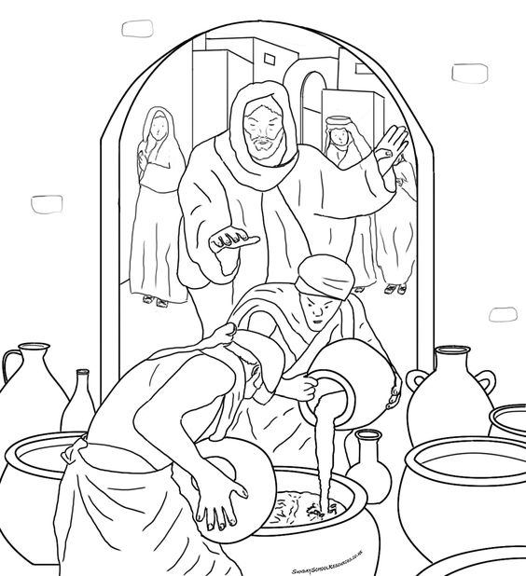  January 26, 2025  Brooklyn Community United Methodist Church  Pastor Jinkyoung You
Welcome to  Brooklyn Community United Methodist Church  January 26, 2025  Third Sunday after the Epiphany  Minister: Pastor Jinkyoung You  Reader: Ila Stephenson  Pianist: Debbie Schneider  Percussionist: Dennis Murphy  Welcome & Greetings  Announcements, Birthdays, Anniversaries  Prelude  CALL TO WORSHIP (Congregation reads the bold)  Be still for a moment. What do you hear? What do you smell? What do you feel under your feet? Beloved, God is here.  In the familiar and unfamiliar, God is here with us.  Take a moment to look around. Whom do you notice? Who isn’t here that you expected to see? Whether this community feels brand new or familiar to you, God is here.  In the familiar and unfamiliar, God is here with us.  Take a deep breath. We share this air, this space, this worship home together. In our breathing and worshiping in this time and place, God is here.  In the familiar and unfamiliar, God is here with us.  God is here. May we pay attention and discern how God brings us together in the familiar and the unfamiliar to be and become the Body of Christ.  May we notice and join in God’s work of forming us for community as we worship today. Amen.  Opening Prayer  *Hymn of Praise ”Fill My Cup, Lord” 2 Times UMH #641 |  |  | Joys and Concerns  Pastoral Prayer/The Lord’s Prayer  *Hymn of Response “In the Garden” UMH #314  Children’s Time  Scripture Readings John 2: 1-11 (CEB)  Congregation Response: Thanks be to God.  “Just a Little Walk with Jesus” Requested by Jan Witzel  Performed by Redeemed Quartet  Message Pastor Jinkyoung You  “Cana Grace and Our Response”  *Offering/Doxology UMH #95  *Hymn of Affirmation UMH #714  “I Know Whom I Have Believed”  Benediction  Postlude  *Stand if you are able.  Please join us for refreshments in our fellowship hall after the service.  If you wish to donate to the church, we now have the collection plate on the table by the entrance to the League Room. Or you can use our on-line giving option found on our website.  UMH United Methodist Hymanl  TFWS In Faith We Sing

