Upcoming Events:  January 14: Spiritual Formation Group 1:30 Chapter 7  January 14: Council Meeting at 6:00  January 18: Coffee and Conversation 9-11  0  Bishop's Convocation of Laity Leadership 2025  February 1, 2025, Black River Falls UMC  Plan for an uplifting, spirit filled day at the Bishops Convocation of Laity Leadership. If you’re a member of the United Methodist church, you are a leader in making disciples for Jesus Christ. The event will feature worshiping with Bishop Schwerin, visioning a grace filled year, hearing from Wisconsin’s delegates to General Conference on what is coming, learning the spiritual impact Faith Alive has had on individual’s lives, and learn our connectionalism with the rest of the world through Midwest Mission. Be a part of this wonderful event February 1st in Black River Falls.  Birthday: “God Bless You and Keep You Another Year Through”  Jeff McNeely January 18  Anniversary:  Kevin and Merrilee Blackmer January 14  If you wish to donate to the church, we now have the collection plate on the table by the entrance to the League Room. Or you can use our on-line giving option found on our website.  Pastor Jinkyoung You  Office Hours: Monday, Tuesday and Thursday 1-3:30 p.m.  Days off: Friday and Saturday  Email: holistic78@gmail.com  Phone number: 608-455-3344 M-Th 9-4. If you need to reach her at other times, please use her private number 256-631-9906. Texting is best if possible.  Email: brooklyncommunityumc@gmail.com  Facebook: Brooklyn Community UMC  Website: http://www.brooklynumc.org/ |  |  | 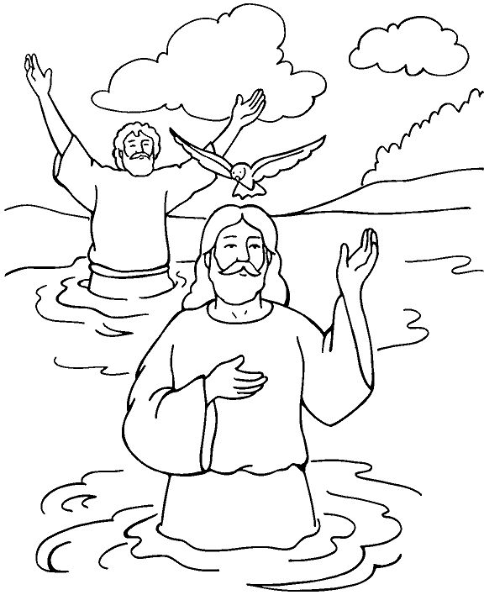  January 12, 2025  Brooklyn Community United Methodist Church  Pastor Jinkyoung You
Welcome to  Brooklyn Community United Methodist Church  January 12, 2025  First Sunday after the Epiphany  Baptism of the Lord  Minister: Pastor Jinkyoung You  Reader: Sheila Olsen  Pianist: Debbie Schneider  Percussionist: Dennis Murphy  Welcome & Greetings  Announcements, Birthdays, Anniversaries  Prelude  CALL TO WORSHIP (Congregation reads the bold)  When we pass through the cleansing waters of baptism and the troubled waters of our lives, God declares:  I will be with you.  When we go through the fires that refine us and the fires that threaten our livelihoods, God declares:  I will be with you.  Even when we travel to the far corners of the earth or down into the depths of our souls, God declares:  I will be with you.  So come, let us worship God whose love never fails, whose presence never leaves, whose mercies never end.  Praise be to God who, in the form of Jesus, waded into the waters of baptism to prove God’s solidarity with us! Amen.  Opening Prayer  *Hymn of Praise ”Joyful, Joyful, We Adore Thee” UMH #89  Joys and Concerns  Pastoral Prayer/The Lord’s Prayer |  |  | *Hymn of Response UMH #420  “Breathe on Me, Breath of God”  Children’s Time  Scripture Readings Luke 3: 15-17, 21-22 (CEB)  Congregation Response: Thanks be to God.  “As the Deer” Sheila Olsen  Message Pastor Jinkyoung You  “Remember Your Baptism”  *Offering/Doxology UMH #95  *Hymn of Affirmation ”Spirit of God” TFWS #2117  Verses 1, 2, 4, 5  Benediction: O God, you made of one blood all nations, and, by a star in the East, revealed to all peoples him whose name is Emmanuel. Enable us who know your presence with us so to proclaim his unsearchable riches that all may come to his light and bow before the brightness of his rising, who lives and reigns with you and the Holy Spirit, now and forever. AMEN.  "Remember that you are baptized, and rejoice!"  Postlude  *Stand if you are able.  Please join us for refreshments in our fellowship hall after the service.  UMH United Methodist Hymanl  TFWS In Faith We Sing

