Upcoming Events:  December 10: No Council Meeting  December 12: Joint Church Conference with Belleville Grace. We are hosting this year. This is an all-church meeting to approve the budget for 2025, Committee appointments and other business. We meet from 6-8. All are welcome.  - Reggie’s Men’s Sock Project for Porchlight begins. Look for the container near the altar. Please bring them to church by December 17.  - Dick Anderson is selling assorted nuts/candies for the Oregon-Brooklyn Lions Club. Order forms are in the Fellowship Hall.  Birthday: “God Bless You and Keep You Another Year Through”  Pastor Jinkyoung December 10  Belinda McKee December 11  Please join us for refreshments in our fellowship hall after the service.  If you wish to donate to the church, we now have the collection plate on the table by the entrance to the League Room. Or you can use our on-line giving option found on our website.  Contact Information:  Pastor Jinkyoung You  Office Hours: Monday, Tuesday and Thursday 1-3:30 p.m.  Days off: Friday and Saturday  Email: holistic78@gmail.com  Phone number: 608-455-3344 M-Th 9-4. If you need to reach her at other times, please use her private number 256-631-9906. Texting is best if possible.  Email: brooklyncommunityumc@gmail.com  Facebook: Brooklyn Community UMC  Website: http://www.brooklynumc.org/ |  |  | 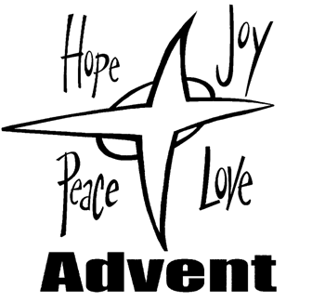  December 8, 2024  Brooklyn Community United Methodist Church  Pastor Jinkyoung You
Welcome to  Brooklyn Community United Methodist Church  December 8, 2024  Second Sunday of Advent  Minister: Pastor Jinkyoung You  Reader: Roxanne Thompson/Rex Tilley  Pianist: Debbie Schneider  Percussionist: Dennis Murphy  Prelude  Welcome  *”Angels from the Realms of Glory” #220  Light the Advent Candle of Hope  The prophet Malachi calls us to watch for the messenger God will send us, a messenger who burns with a passion for God’s coming salvation. “For he is like a refiner's fire and like fullers' soap; he will sit as a refiner and purifier of silver, and he will purify the descendants of Levi and refine them like gold and silver, until they present offerings to the LORD in righteousness” (Malachi 3:2b-3).  In a world driven by a passion to maintain the status quo, we choose to live with a passion for God’s peace, to listen to those who call us to righteousness, and to submit ourselves to God’s grace, that we might be refined and purified until we reflect God’s love throughout the earth. |  |  | We light this candle of peace as a sign of our commitment to passionately pursue the work of making peace in our hearts, our families, our communities, and throughout the earth until God’s kingdom comes on earth as it is in heaven.  Opening Prayer  *”Love Came Down at Christmas” #242  *Passing of Peace  Announcements, Joys, and Concerns  Pastoral Prayer/ The Lord’s Prayer  “O Holy Night” Pat Anderson  Scripture Readings John 14:27; Luke 2: 8-11 (CEB)  Congregation Response: Thanks be to God.  Message Pastor Jinkyoung You  “Advent: peace”  Offering/Doxology  *”Let There Be Peace on Earth” #431  Benediction  Postlude  *Stand if you are able.

